From Raw Data to a Real Answer
Month 2 Project Guide
P1: Does an “A” Mean the Same Thing Twice? · Gate 2 worked solutions · what has been done and how to explore it

Prepared for: Yugal Poudel
Repository: Yugalpoudel07/From-Raw-Data-to-a-Real-Answer
Date: 2 October 2026

Contents
1. Summary
2. Where everything is
3. Project P1: the walkthrough (question, data, cleaning, method, results, robustness, limitations)
4. How to run P1 and check it yourself
5. Gate 2: worked solutions and how to use them
6. Also done: matplotlib and seaborn modules
7. What is still open in Month 2

1. Summary
This guide walks through the last pieces of Month 2 of the 12-month plan (“From raw data to a real answer”): Project P1, the worked solutions for Gate 2, and the matplotlib and seaborn modules finished just before them. It says what was built, why each decision was made, where every file is, and how to check the work yourself.
The P1 finding in one sentence. About 3 in 10 A grades in New York City restaurant windows were earned only after a failed surprise inspection, and those restaurants failed their next surprise inspection 51.6% of the time, against 33.1% for restaurants that earned their A first time: a gap of 18.5 percentage points (95% CI 17.5 to 19.5).

What was done
Piece | Status | Where
matplotlib official tutorials | Done: 7 notebooks, run with outputs, README updated | matplotlib - official tutorials/
seaborn official tutorial | Done: 13 notebooks, run with outputs, README updated | seaborn - official tutorial/
Project P1 (NYC restaurant grades) | Built and reproducible; still to be pushed to GitHub | P1 - NYC Restaurant Grades/
Gate 2 worked solutions | SQL, pandas and chart solutions done; clean-machine run of P1 passed | Gate 2 - worked solutions/
Gate 2 itself (closed book) | Still to do: you sit it, timed, without notes | see section 5
Main repository README | Updated with the new modules, P1 and Gate 2 | README.md

Honest note on Gate 2. The roadmap's Gate 2 is a closed-book, 90-minute test you sit yourself, plus a stranger running P1. You asked for worked solutions, so that is what this folder holds. It is study material for the gate; it does not pass it. Section 5 explains how to use it.

2. Where everything is
All paths are inside the repository folder From-Raw-Data-to-a-Real-Answer on your computer.
Folder / file | What it contains
P1 - NYC Restaurant Grades/README.md | The project page a stranger reads first: question, answer, how to run, cleaning, results, limitations
P1 .../run_all.py | One command that downloads the data, runs both notebooks and rebuilds every figure and number
P1 .../notebooks/01_data_quality_and_cleaning.ipynb | Quality report, 7 documented cleaning steps, tidy tables, DuckDB database
P1 .../notebooks/02_analysis_and_figures.ipynb | Inspection cycles, bootstrap CIs, permutation test, figures 1-6, robustness checks
P1 .../src/ | cleaning.py (data_quality_report), analysis.py, plotting_utils.py, download_data.py, paths.py
P1 .../figures/ | 7 publication figures, 300 dpi
P1 .../results/key_numbers.json | Every number quoted in the README, saved by the notebook
Gate 2 - worked solutions/ | 01 SQL, 02 pandas, 03 charts notebooks, 04 artifact-test checklist, README
matplotlib - official tutorials/Notebook/ | 7 notebooks, one per docs page
seaborn - official tutorial/Notebook/ | 13 notebooks, one per tutorial page plus heatmap

Suggested reading order
- P1 README (10 minutes): the whole story at a glance.
- P1 notebook 01: how messy the raw file was and why each cleaning step exists.
- P1 notebook 02: how the comparison is built and why the confidence intervals resample restaurants.
- Gate 2 notebook 01 (SQL): the same headline number rebuilt with window functions.
- Gate 2 notebooks 02 and 03, then the artifact-test checklist.

3. Project P1: the walkthrough

3.1 The question, stated before any analysis
Does an “A” in a New York City restaurant’s window mean the same thing whether it was earned at the first, unannounced inspection or only after a re-inspection?
Why this question: the roadmap asks for a question at the top, real messy public data and a conclusion that answers the question. This one is concrete, has a yes/no answer that can be measured with uncertainty, and matters to anyone who has eaten in New York.

How NYC grading works (you need this to read the data)
- Inspectors score violations in points. Lower is better: 0-13 = A, 14-27 = B, 28+ = C.
- At the unannounced initial inspection, 0-13 points earns an A on the spot.
- 14 or more gives no grade that day. About a month later there is a re-inspection, and the grade card is based on that visit.
- So the same A card can mean “clean on a surprise visit” or “failed the surprise visit, then passed one it was expecting”. A diner can’t tell which.

3.2 The data
Item | Detail
Source | NYC Department of Health (DOHMH) Restaurant Inspection Results, NYC Open Data, extracted December 2018
Copy used | A 300,000-row random sample published by TidyTuesday (the full file is over GitHub’s 100 MB limit)
Unit of the raw file | One row per violation cited at one inspection
Download | src/download_data.py fetches it (96 MB) and verifies a SHA-256 checksum
After cleaning | 135,864 inspections of 25,744 restaurants, January 2015 to December 2018

Why this dataset: it is government data, genuinely messy (see below), large enough for tight confidence intervals, and it splits naturally into three tables, which also made it useful for the SQL part of Gate 2. The other options you were offered were Seattle bike counters and Philadelphia parking tickets.

3.3 What was messy: the data-quality report
The reusable function data_quality_report(df) in src/cleaning.py (also a Week 6 build task) reports type, missing values, unique values, IQR outliers and likely type problems for every column. It found:
- 75 fully duplicated rows.
- 796 rows dated 01/01/1900, which the data dictionary defines as “not yet inspected”.
- Mojibake: “CafÃ©/Coffee/Tea” is “Café” read with the wrong encoding (the Kaggle Data Cleaning lesson on encodings, met in the wild).
- 65 negative scores (-1 points is impossible).
- The text value “Missing” in the borough column instead of a real missing value.
- Grades missing on half the rows. This is expected and meaningful: a failed initial inspection gets no grade.
- Dates and zip codes stored as text and floats.

3.4 Cleaning decisions, each with a reason
# | Step | Why | Rows before | Rows after
1 | Drop exact duplicates | No extra information | 300,000 | 299,925
2 | Drop 01/01/1900 rows | Placeholder for “not yet inspected”; no score, no type | 299,925 | 299,129
3 | Keep 2015 onward | Only 462 stray rows from 2012-14 | 299,129 | 298,667
4 | Fix Café; fill 23 “Missing” boroughs | Encoding error; all have zip 11249, which is Brooklyn everywhere else | 298,667 | 298,667
5 | Negative scores to missing | Points can’t be negative | 298,667 | 298,667
6 | One row per inspection | Score and grade belong to the inspection | 298,667 | 135,871
7 | Drop conflicting-score inspections | 7 inspections; no way to tell which is final | 135,871 | 135,864

A check worth knowing about: a grade derived from the score agrees with the official grade on 99.4% of 75,265 inspections. Almost all the disagreements (406 of 439) are reopening inspections, where a restaurant the city closed reopens after a clean visit but keeps its C.
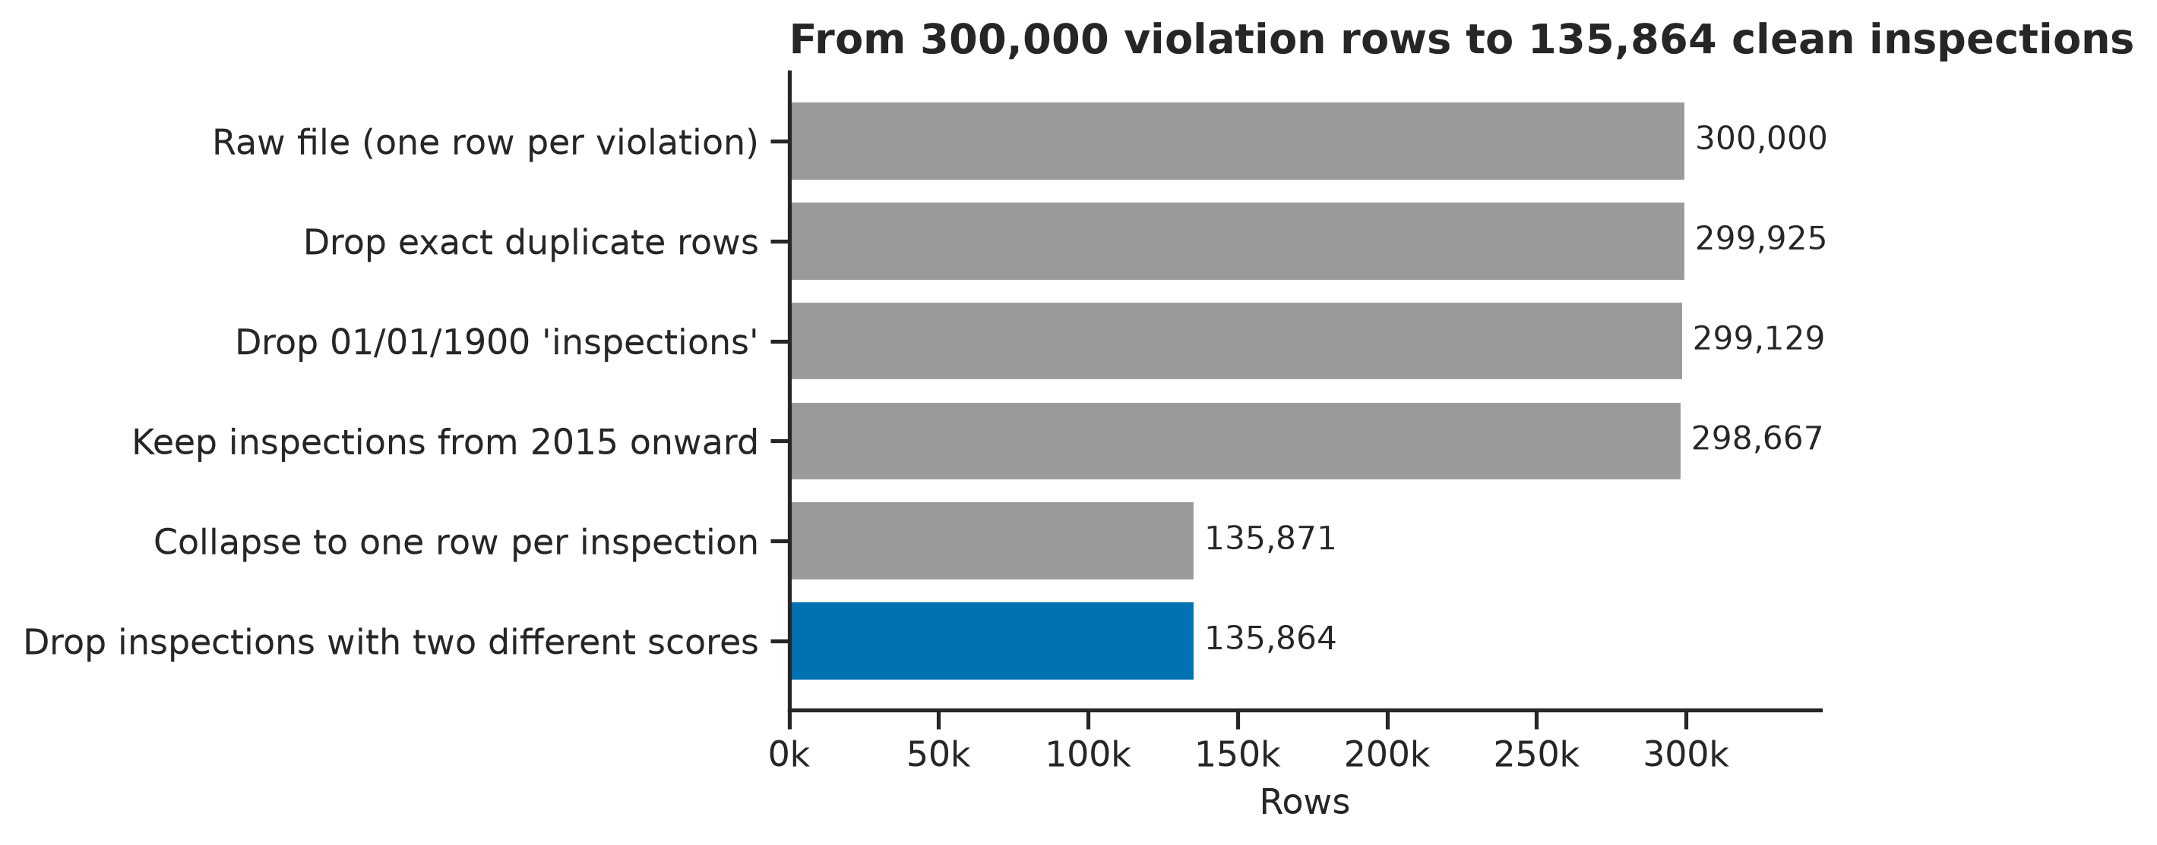
Figure 7. The cleaning funnel: from 300,000 violation rows to 135,864 inspections.

3.5 Method
- Keep scored routine (“cycle”) inspections: initial inspections and re-inspections.
- Label every A by route: A at initial (surprise visit scored 0-13) or A after re-inspection (surprise visit 14+, then the next cycle inspection, a re-inspection within 120 days, scored 0-13).
- Follow each A to the restaurant’s next surprise inspection. Outcome: did it fail (14+)?
- Uncertainty: the same restaurant appears many times, so all 95% confidence intervals use a cluster bootstrap that resamples whole restaurants (2,000 resamples, fixed seed). A permutation test with one A per restaurant checks the gap isn’t noise.
- Robustness: one A per restaurant only, 2015-2016 grades only, and splits by time to the next inspection.
59,896 A grades were found; 41,190 of them, at 18,825 restaurants, have a later surprise inspection in the data and enter the comparison.

3.6 Results

The centrepiece
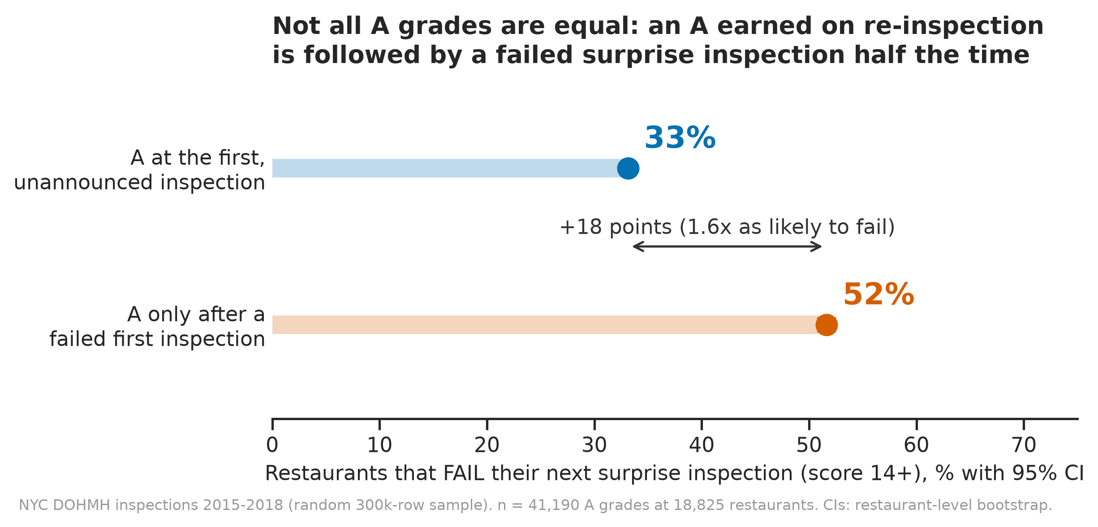
Figure 1. Fail rate at the next surprise inspection, by how the A was earned (95% CIs).
Measure | A at initial | A after re-inspection | Difference (95% CI)
Fails next surprise inspection | 33.1% | 51.6% | +18.5 points (17.5 to 19.5)
Relative risk of failing | 1 (reference) | 1.56x | 1.52 to 1.59
Mean next score (lower is better) | 14.4 | 18.7 | +4.2 points (4.0 to 4.5)
Share of all A grades | 68.9% | 31.1% | 31.1% CI: 30.6% to 31.5%

Permutation test (one A per restaurant, 18,825 restaurants, 10,000 shuffles): the observed gap is 19.2 points; the largest shuffled gap was 3.2 points, so p < 0.001.

How common is each route?
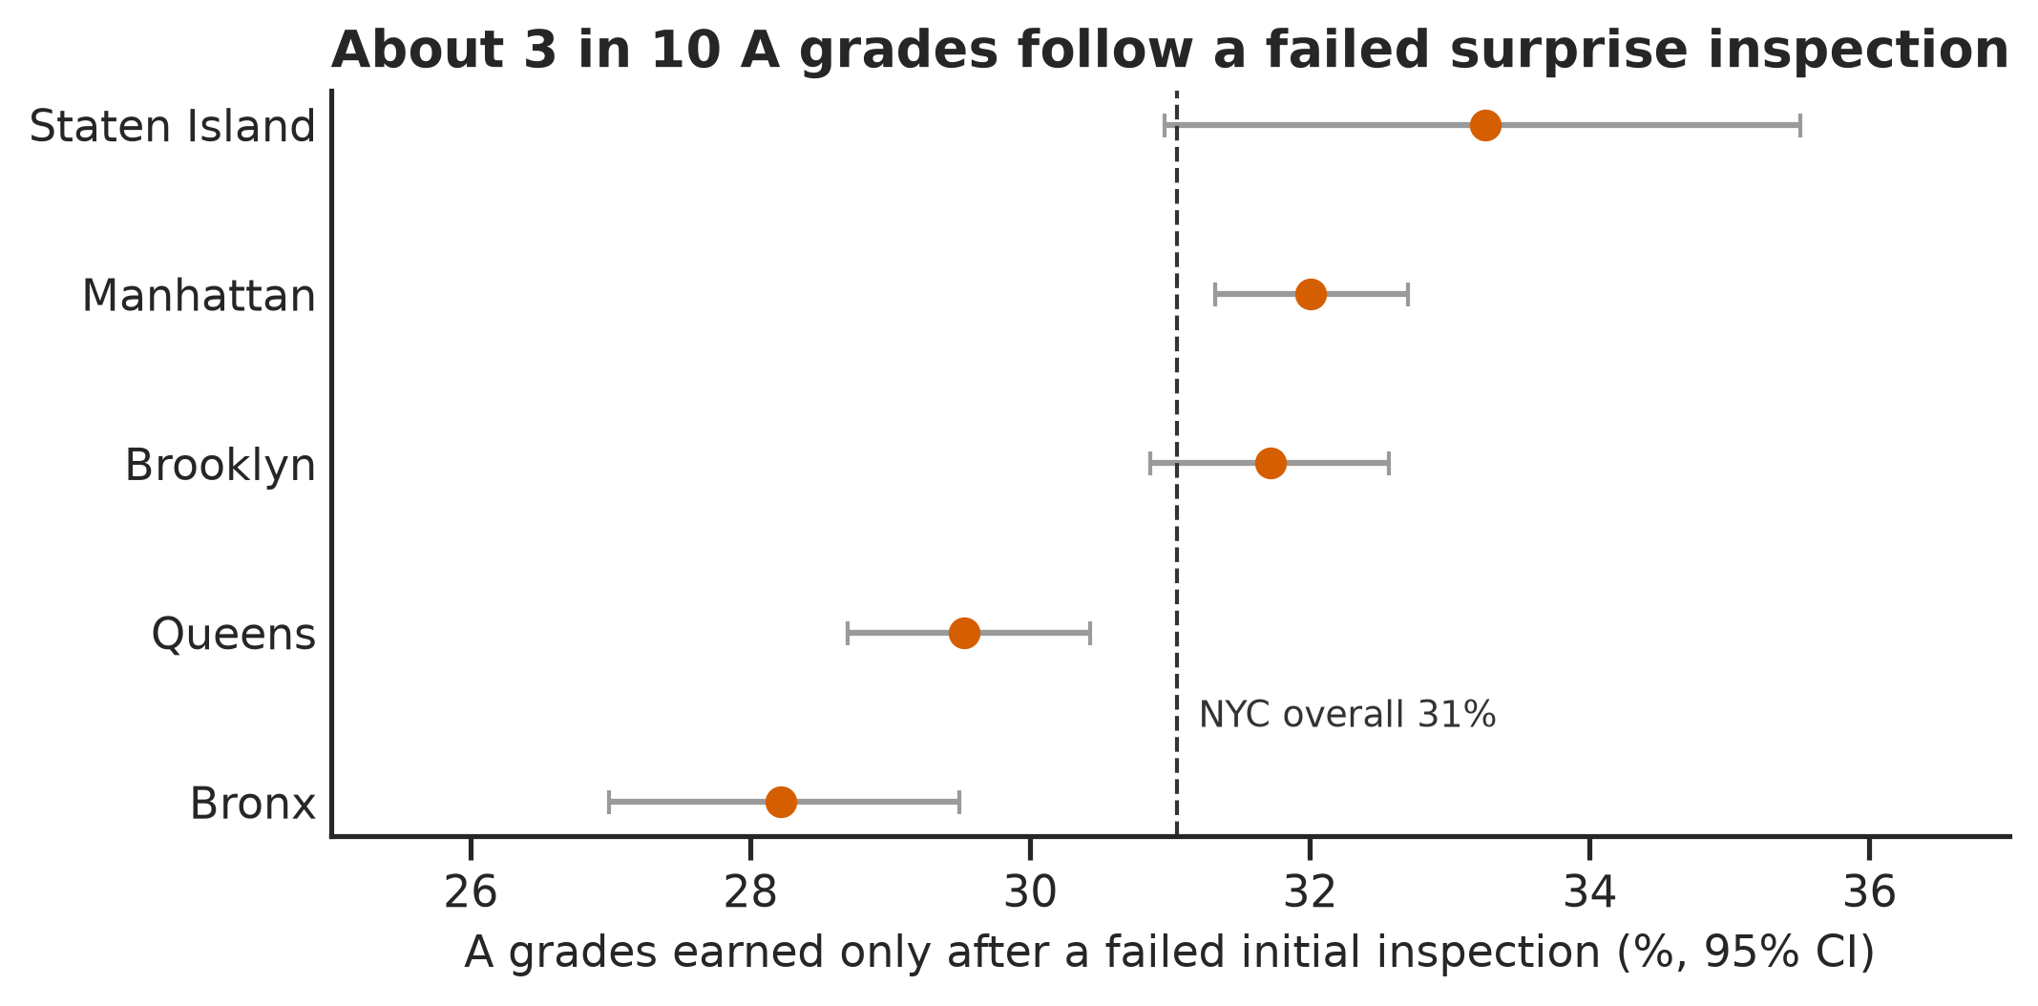
Figure 2. Share of A grades earned only on re-inspection, by borough.

The whole distribution, not just the pass/fail line
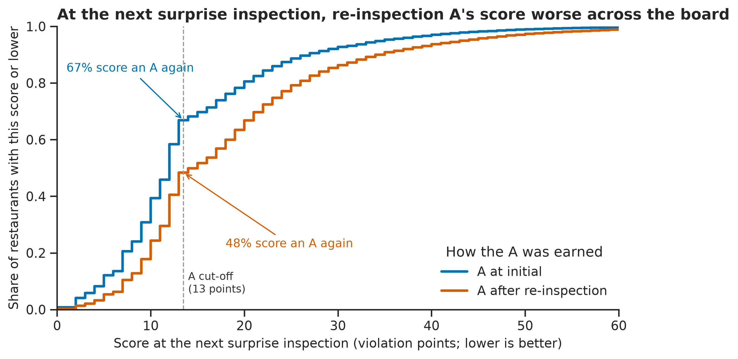
Figure 3. ECDF of the next surprise-inspection score. The re-inspection-A curve sits to the right everywhere.

Why: the surprise score carries the information
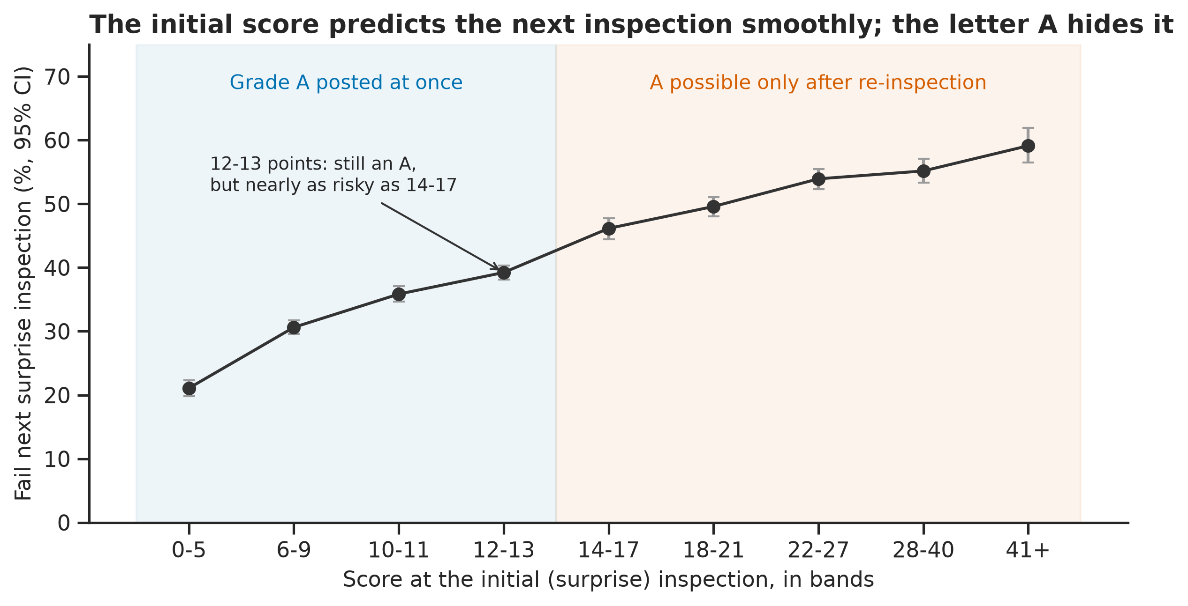
Figure 4. Risk of failing the next surprise inspection rises smoothly with the initial score; there is no jump at the A line.
The risk climbs steadily, from about 1 in 5 for restaurants that scored 0-5 points to about 3 in 5 for 41+. The letter A cuts this continuum in two and throws the rest away.

Every borough, and an A is often a narrow pass
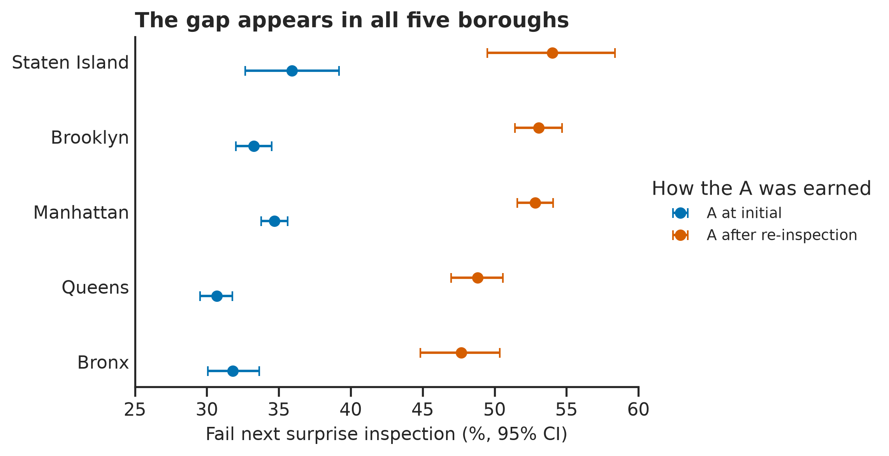
Figure 5. The gap appears in all five boroughs.
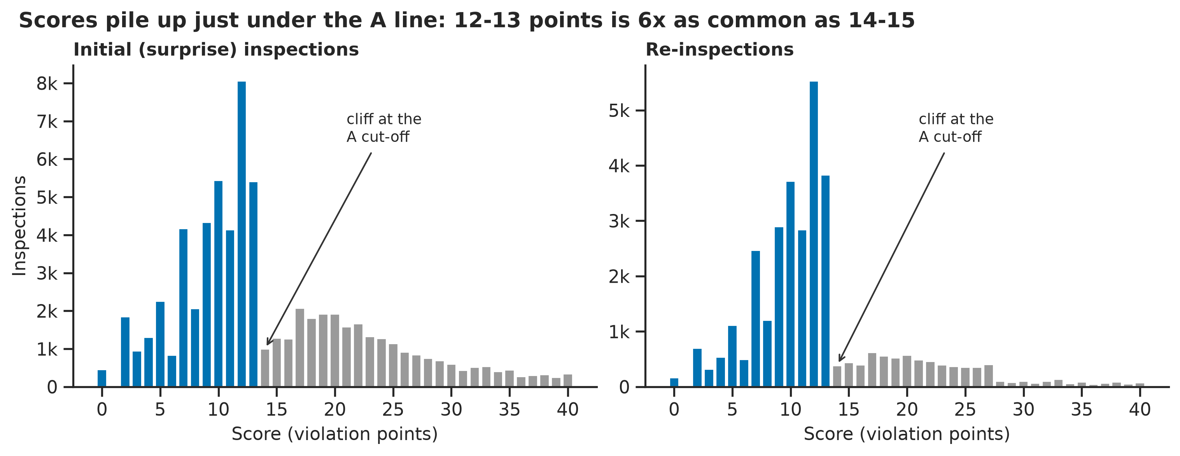
Figure 6. Scores pile up at 12-13 points, just under the A line: 5.9x as common as 14-15 (95% CI 5.6 to 6.2).

3.7 Robustness checks
Check | n | First-time A fails | Re-inspection A fails | Gap (95% CI)
All A grades (main result) | 41,190 | 33.1% | 51.6% | +18.5 (17.5 to 19.4)
First A per restaurant only | 18,825 | 32.2% | 51.4% | +19.2 (17.8 to 20.7)
A posted 2015-2016 | 22,820 | 32.3% | 48.2% | +15.9 (14.5 to 17.2)
Next inspection < 8 months | 15,560 | 44.9% | 51.9% | +7.0 (5.0 to 9.1)
Next inspection 8-14 months | 18,865 | 31.8% | 52.1% | +20.3 (18.2 to 22.5)
Next inspection > 14 months | 6,765 | 30.9% | 36.5% | +5.6 (-0.0 to 11.2)

The gap always points the same way, but it is much smaller when the next inspection comes unusually soon or late, and the small > 14-month group is inconclusive on its own. (These rows use 1,000 bootstrap resamples, which is why the first row’s upper bound differs by 0.1 from the headline.)
A check that was rejected, and why. Comparing the two routes within the same restaurant reverses the sign (56% vs 40%). With only about 3.5 years of data, a restaurant shows both routes only if it alternates between passing and failing, so selecting those restaurants selects on the outcome. Explaining why a tempting check is biased is the kind of thing interviewers ask about.

3.8 Limitations: what P1 cannot prove
- Not causal. It shows what a re-inspection A predicts, not that re-inspections are lax or that grading changes behaviour.
- Regression to the mean. A bad surprise score includes some bad luck, so those restaurants should improve, and they do (24.6 to 18.7 points), but not to the first-time-A level (14.4).
- Sampled rows. The file is a random sample of violation rows; inspections with few violations are more likely to be missing entirely.
- Inspection timing is not random. The city inspects worse restaurants sooner, and the gap shrinks when timing is unusual.
- Survivorship. Only restaurants with an active permit in December 2018 are included.
- Scores are not illness. Nothing here measures food-borne illness.
- 2015-2018 only. Rules and practice have changed since.

4. How to run P1 and check it yourself
From inside the P1 folder, with Python 3.10 or newer and an internet connection for the first step:
pip install -r requirements.txt
python run_all.py
run_all.py downloads the raw file and checks its checksum, runs notebook 01 (tidy tables and a DuckDB database in data/processed/), then notebook 02 (figures and results). It takes about 70 seconds after the download.
How to know you reproduced it: open results/key_numbers.json. fail_next_A_after_reinspection should start with 0.5163 and fail_next_A_at_initial with 0.3313. Every random step has a fixed seed, so all the numbers match.

The clean-machine test that was run
To check the README is complete, the P1 folder was copied without any data, figures or results into a brand-new Python virtual environment, and only the two commands above were run.
Item | Result
Install from requirements.txt alone | Worked (pandas 3.0.6, matplotlib 3.11.2, seaborn 0.13.2, duckdb 1.5.6)
Download and checksum | OK
Notebook 01 / notebook 02 | 31 s / 37 s, no errors or warnings
Figures | All 7 created
key_numbers.json vs published | Identical

Not covered: Windows and older Python versions. That is part of what the person in the artifact test will check.

Before you publish P1
- Commit the P1 folder and push it to GitHub (the roadmap requires it to be public). The .gitignore already excludes the 96 MB raw file and the generated data.
- Leave the line-ending-only changes to .gitignore and LICENSE out of the commit.
- Read both notebooks end to end until you can explain every step without notes. You will be asked about this project in interviews.

5. Gate 2: worked solutions and how to use them
The roadmap’s Gate 2 (Week 8) is closed book and 90 minutes:
Part | Time | Task | Worked solution
1 | 45 min | SQL, no reference: three queries, one with a partitioned window function | 01_SQL notebook
2 | 20 min | pandas: a groupby-merge-reshape chain for a described dataset | 02_pandas notebook
3 | 10 min | Charts: name the right chart and justify it against two alternatives | 03_Charts notebook
4 | - | Artifact test: a person with no context runs P1 and states the finding | 04_Artifact test.md

Part 1: SQL (DuckDB on P1’s three tables)
- Q1 joins, GROUP BY and HAVING: the 10 cuisines with the worst surprise-inspection scores (Indian, Korean and delicatessens lead, at about 19-20 points), plus a check that the join kept every row.
- Q2 LAG() OVER (PARTITION BY camis ORDER BY date): the city waits a median 381 days after an A, but only 235 after a B-range and 217 after a C-range score. The notebook also shows that without PARTITION BY, 22,536 rows would be compared with a different restaurant.
- Q3 RANK() OVER (PARTITION BY boro ...) in a CTE, filtered in the outer query: the top 3 cuisines by failure rate in each borough, plus ROW_NUMBER vs RANK vs DENSE_RANK.
- Bonus P1’s headline rebuilt in SQL with LEAD and a named WINDOW. It matches pandas exactly (33.13% and 51.63%). This also covers the Week 8 task “do one analysis in both SQL and pandas”: SQL was clearer for the previous/next-row logic, pandas for the statistics and charts.

Part 2: pandas
Question: what percentage of surprise inspections cited at least one critical violation, by borough and year? The answer is one chain: groupby (violations to one row per inspection), two merges with validate=, groupby, then unstack. About 80-87% everywhere. The notebook also shows the indicator=True check and how an inner join would have quietly inflated the answer.

Part 3: charts
Three questions, each drawn as the right chart beside the two alternatives it beats: box plots for distributions across boroughs; a line with a 95% band for a four-year trend (which also reveals a seasonal cycle, with A shares highest from January to May); binned rates with CIs for a numeric predictor and a yes/no outcome. It ends with a 60-second answer template.

Part 4: artifact test
The clean-machine run in section 4 passed. The person test is still yours: send someone the P1 link with no explanation, use the checklist in 04_Artifact test.md, and log the result. The gate passes when they can state the question, give the finding and run the project.

How to actually pass Gate 2
- Don’t read the solutions first. For each part, write your own answer with a timer running and no notes.
- Compare with the worked solution and write down every difference.
- A few days later, sit a fresh version: new SQL questions on the same database, a new pandas question, three new chart questions.
- Run the person artifact test.

6. Also done: matplotlib and seaborn modules
Both follow the pattern of your pandas User Guide module: one notebook per docs page, docs headings, commented code, every example run with outputs saved, a Key takeaways table at the end, and the READMEs updated with ticks, badges and notebook tables.
Module | Notebooks | Highlights
matplotlib (3.11.2) | 7 | Quick Start, Lifecycle of a Plot, Artist tutorial (with the setters-only exercise), constrained and tight layout, arranging Axes, annotations, choosing colormaps
seaborn (0.13.2) | 13 | All 12 tutorial pages plus the heatmap API page; docs’ random seeds kept so outputs match the website

P1 put several Week 7 build tasks to work: plotting_utils.py (style, colour-blind palette, 300 dpi save), a figure that argues one finding (figure 1), a histogram and density, ECDF, small multiples and a scatter with a trend line in the module notebooks.

7. What is still open in Month 2
Item | Notes
Gate 2 (closed book) | Sit it yourself; use section 5
Artifact test with a person | Checklist ready in 04_Artifact test.md
Push P1 to GitHub | Required: “public on GitHub”
Week 5 build tasks | Permutation test from scratch, p-hacking simulation, power analysis
Khan Academy significance tests | 40+ problems logged
15 SQL business questions | The P1 DuckDB database is a ready multi-table dataset; Gate 2 notebook 01 covers 4
Bad chart from the wild, reproduced and fixed | Plus a 150-word write-up
Storytelling with Data | Study guide exists; reading not started
Daily SQL habit and lab-notebook entries | Ongoing

The trap the roadmap warns about this month: making P1 perfect instead of finished. It is finished and reproducible. Push it, run the artifact test, and move on.

